Software Requirements Specification
for
Recipe Book Database Management
Version 1.0
Prepared by:
Anusha V
Sahitya K
Sayali Sachin Chorge
Manipal Institute of Technology, Manipal
29-February-2024
Table of Contents
Table of Contents ii
Revision History ii
1. Introduction 1
1.1 Purpose 1
1.2 Document Conventions 1
1.3 Intended Audience and Reading Suggestions 1
1.4 Product Scope 1
1.5 References 1
2. Overall Description 2
2.1 Product Perspective 2
2.2 Product Functions 2
2.3 User Classes and Characteristics 2
2.4 Operating Environment 2
2.5 Design and Implementation Constraints 2
2.6 User Documentation 2
2.7 Assumptions and Dependencies 3
3. External Interface Requirements 5
3.1 User Interfaces 5
3.2 Hardware Interfaces 5
3.3 Software Interfaces 5
3.4 Communications Interfaces 5
4. System Features 7
4.1 System Feature 7
5. Other Nonfunctional Requirements 10
5.1 Performance Requirements 10
5.2 Safety Requirements 10
5.3 Security Requirements 10
5.4 Software Quality Attributes 10
5.5 Business Rules 10
6. Other Requirements 11
Appendix A: Glossary 12
Appendix B: Analysis Models 13
Appendix C: To Be Determined List 13

Revision History
Name | Date | Reason For Changes | Version

Introduction

Purpose
This Software Requirements Specification (SRS) details the functional and non-functional requirements for the Recipe Book, a web application built using Node.js, PHP and MySQL This document outlines the scope of the entire system, covering user functionalities like creating profiles, setting food preferences, browsing curated recipes, interacting with recipes through likes and comments, and exploring detailed recipe pages with ordering options from nearby restaurants.

Document Conventions
This SRS adheres to the following stylistic conventions:
• Headings: Level 1 headings are bolded and centered, and Level 2 headings are bolded.
• Numbering: Sections are numbered using a bullet point system.
• Text Style: Requirements are written in plain language, avoiding technical jargon whenever possible. Italics are used to emphasize specific terms or phrases within requirements.
• Priorities: Every requirement statement has an explicitly assigned priority (e.g., High, Medium, Low) to reflect its relative importance within the project.
These conventions aim to promote clarity, consistency, and ease of navigation within the SRS document.

Intended Audience and Reading Suggestions
• Developers: Gain a comprehensive understanding of the system's functionality and technical requirements.
• Project Managers: Utilize the document for project planning, resource allocation, and risk assessment.
• Testers: Derive test cases based on the functional and non-functional requirements outlined in the document.
• Documentation Writers: Use the document as a reference for creating user manuals and other supporting materials.
The document is organized into sections with increasing levels of detail, starting with:
• Introduction: Provides a high-level overview of the project, scope, and target users.
• System Requirements: Defines the overall system functionalities and constraints.
• Functional Requirements: Details user-facing features and functionalities.
• Non-Functional Requirements: Outlines performance, security, usability, and other non-functional aspects.
Recommended reading sequence:
1. Introduction: All audience members.
2. System Requirements, Functional Requirements, Non-Functional Requirements: Developers, Testers.
3. Specific sections within Functional Requirements: Project Managers, Documentation Writers (based on their specific areas of focus).
This approach ensures each reader can efficiently access the information most relevant to their role in the project.

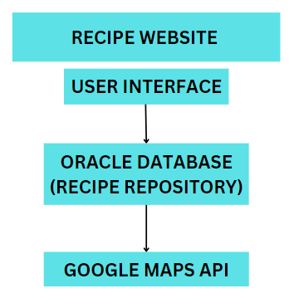
Product Scope
The Recipe Book is a web application designed to revolutionize the online recipe exploration experience. It caters to a diverse range of users, offering personalized recipe recommendations, engaging community features, and a seamless connection between virtual culinary inspiration and real-world dining enjoyment. The Recipe Book aligns with the corporate goal of expanding market reach and user engagement within the culinary space. By fostering a user-centric platform that caters to individual preferences and fosters community interaction, the application aims to:
• Attract and retain a wider audience by offering a personalized and engaging culinary experience.
• Increase user engagement through interactive features like food preference customization, recipe liking and commenting, and activity sections.

References
- UI Style Guide, v1.2, 2024-02-15, Internal Document (Accessible on company intranet)
• System Requirements Specification (SRS): Recipe Book System Requirements Specification, v1.0, 2024-02-20, Internal Document (Accessible on project management platform)
• Use Case Documents: Recipe Book Use Case Documents, v1.1, 2024-02-22, Internal Document (Accessible on project management platform)

Overall Description

Product Perspective
The specified Software Requirements Specification (SRS) pertains to a new, self-contained product, namely a website designed to provide users with recipes. This product is not a follow-on member of an existing product family nor a replacement for any existing systems; rather, it is a standalone solution tailored to meet the specific needs of users seeking culinary guidance and inspiration. The website's primary function is to serve as a repository of recipes, offering users a wide range of culinary options spanning different cuisines, meal types, and dietary considerations. It aims to provide an intuitive interface for users to search, browse, and discover recipes based on their preferences and requirements.

Key components:
- User Interface: Allows users to interact with the website, including searching, browsing, and viewing recipes.
- Database (Recipe Repository): Stores recipe data, including ingredients, instructions, and user preferences.
- Google Maps API: Provides functionality for mapping and location-based services, possibly for displaying recipe origins or nearby grocery stores.
- Interfaces: The user interface interacts with both the recipe database and the Google Maps API to provide users with recipe information and possibly location-based features.

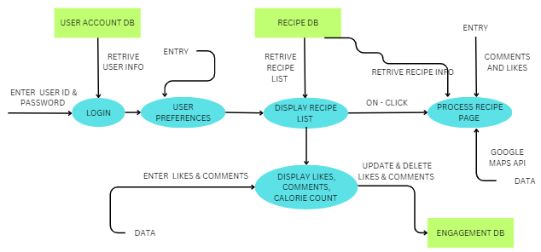
Product Functions
- Recipe Exploration:
Users can effortlessly browse through a diverse collection of recipes categorized by cuisine, meal type, and dietary preferences.
Intuitive navigation allows for easy exploration and discovery of new recipes.
- Robust Search Capability:
A powerful search functionality enables users to find specific recipes quickly by entering keywords or applying advanced filters such as cooking time, difficulty level, and calorie count.
- Comprehensive Recipe Details:
Detailed recipe pages provide users with all the necessary information, including ingredients, step-by-step instructions, nutritional facts, and user-generated rating
s and comments.
- Engagement and Personalization:
Users can engage with the community by rating recipes, leaving comments, and saving their favorite recipes for future reference.
Personalization features allow users to create profiles, customize preferences, and curate their own collections of recipes.
- Seamless Account Management:
Streamlined account creation and login processes facilitate user engagement while ensuring security and privacy.
User-friendly account management tools empower users to update profiles, manage saved recipes, and control account settings effortlessly.
- Integration with Google Maps API:
Integration with the Google Maps API enriches the user experience by providing location-based services, potentially offering insights into recipe origins or suggesting nearby grocery stores for ingredient procurement or direct restaurants available close by.

User Classes and Characteristics
- General Users:
- Description: Regular users who visit the website to find recipes, browse categories, and explore culinary ideas.
- Characteristics: Varied frequency of use, basic technical proficiency, seeking culinary inspiration and guidance.
- Active Contributors (Commenters):
- Description: Users who engage with the community by leaving comments, sharing cooking tips, and providing feedback.
- Characteristics: Regular participation, comfortable with interactive features, contribute to discussions and interactions.
- Recipe Enthusiasts (Most Viewed/Liked):
- Description: Users who frequently explore popular and trending recipes for cooking inspiration.
- Characteristics: Regular visitors, proficient in website navigation, seek out trending and popular recipes for culinary exploration.
- Administrators (Moderators):
- Description: Site administrators responsible for managing user-generated content and enforcing community guidelines.
- Characteristics: Regular monitoring and management of site activities, advanced technical skills in website administration and content management.

Operating Environment
Environment Description:
The recipe website will operate on web browsers across various devices (desktops, laptops, tablets, smartphones). It's compatible with common operating systems (Windows, macOS, iOS, Android) and major browsers (Google Chrome, Microsoft Edge). Hosting requires a web server (e.g., HTTP Apache), a relational database (e.g., MySQL, Oracle DB), and integration with the Google Maps API. Client-side tech includes HTML, CSS, JavaScript) while server-side scripting may use PHP or Node.js.

Design and Implementation Constraints
- Oracle Database Requirement:
- Developers are constrained to use Oracle Database, limiting options for alternative database management systems.
- Google Maps API Integration:
- Integration with the Google Maps API dictates specific protocols and APIs, restricting flexibility in communication methods.
- Security and Regulatory Compliance:
- Adherence to corporate policies and regulatory standards, alongside security considerations, imposes strict constraints on data handling and access control measures.

User Documentation
1. User Manual:
- A comprehensive guide detailing website navigation, feature usage, and account management.
2. Online Help (FAQ’s):
- Contextual assistance within the website to aid users in real-time.
3. Tutorials:
- Step-by-step guides for common tasks such as recipe search and account customization.
4.Delivery Format/Standards:
- Documentation will be available digitally on the website, adhering to standard conventions for clarity and usability.

Assumptions and Dependencies
Assumed Factors Affecting Requirements:
- Third-Party Component Reliability:
- Assumed reliability of third-party components like Google Maps API could impact location-based services.
- Data Privacy and Security Compliance:
- Assumed compliance with data privacy regulations may influence data handling and security measures.
- Scalability and Performance Assumptions:
- Assumed scalability and performance capabilities of the hosting environment may affect website optimization.

Dependencies on External Factors:
- Google Maps API Integration:
- The project depends on the reliable availability and functionality of the Google Maps API.
- Oracle Database Integration:
- Reliance on Oracle Database for backend data storage and management.

External Interface Requirements

User Interfaces
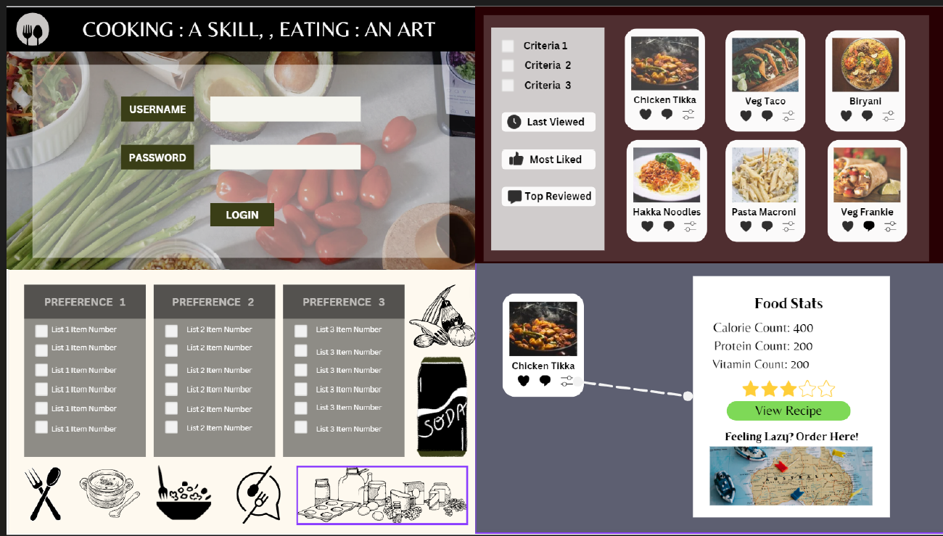
- Components:
Navigation menus, search bars, recipe cards, detail pages, comment sections, and user profiles form key interface elements.
- GUI Standards:
Adherence to established GUI standards and product family style guides ensures consistency and familiarity.
- Layout Flexibility:
Screen layouts are responsive, ensuring optimal display across various devices and screen sizes.
- Standard Functions:
Common buttons (search, login) and functions (filtering, sorting) are accessible from every screen for user convenience.
- Sample Screen Images:
Sample screen images may be provided in the user interface specification to illustrate the layout, design elements, and functionality of the interface components.

Hardware Interfaces
The software product interfaces with various hardware components, including desktops, laptops, tablets, and smartphones. Data interactions involve exchanging recipe information and user preferences, while control interactions encompass user inputs and system responses. Communication protocols like HTTP and HTTPS facilitate data transmission. Physical interactions occur via input/output devices such as keyboards, touchscreens, and displays. The software is platform-independent, supporting major operating systems like Windows, macOS, Linux, iOS, and Android, ensuring compatibility across diverse hardware environments.

Software Interfaces
The recipe website interacts with several software components, including:

- Database Management System:
- Name: Oracle Database
- Purpose: Stores recipe data, user information, and interaction logs.
- Data Items: Recipes, user profiles, comments, ratings.
- Services: CRUD operations (Create, Read, Update, Delete) for recipe and user data.
- Operating System:
- Name: Windows / MacOS
- Purpose: Hosts the web server and provides the underlying environment for running the website.
- Communication: HTTP/HTTPS protocols for client-server communication.
- Web Server:
- Name: Apache HTTP Server
- Purpose: Serves web pages, handles HTTP requests, and communicates with the database.
- Services: HTTP request handling, static and dynamic content delivery.
- Communication: Apache server modules for processing requests and responses.
- Frontend:
- Name: HTML, CSS, JavaScript
- Purpose: Provides the frontend interface for users to interact with the website.
- Communication: Google API for map navigation
- Backend Framework:
- Name: Node.js, PHP
- Purpose: Implements server-side logic, handles user requests, and communicates with the database.
- Services: Routing, request handling, authentication, data validation.

Communications Interfaces
- Web Browser Communication:
- Use HTTP/HTTPS protocols for data exchange with web browsers.
- Network Server Communication:
- Employ TCP/IP protocols for reliable data transmission.
- Electronic Forms:
- Transmit form data via HTTP POST requests.
- Security Measures:
- Implement HTTPS/TLS for encrypted communication to protect user data.
- Synchronization Mechanisms:
- Use WebSocket or polling for real-time data synchronization between client and server.

System Features

System Features
4.1.1 Description and Priority

Feature: User Authentication

Description: User authentication is a fundamental security feature that enables users to securely access the website by verifying their identity through login credentials such as username/email and password. This feature is essential for ensuring the confidentiality and integrity of user accounts and sensitive data. It provides a barrier against unauthorized access, protecting user information and maintaining trust in the platform. Additionally, user authentication lays the groundwork for implementing personalized features, such as saved preferences and user-specific content recommendations, enhancing the overall user experience.
Priority: High
Priority Component Ratings:
- Benefit: 9
- User authentication enhances security, builds user trust, and enables personalized features, improving the overall user experience.
- Penalty: 7
- Without proper authentication, there's a risk of unauthorized access, data breaches, and compromised user accounts, leading to reputational damage and potential legal consequences.
- Cost: 6
- Implementing user authentication requires development resources to design and integrate secure login functionality, including user registration, password hashing, and session management.
- Risk: 8
- Failure to implement robust user authentication poses significant security risks, including data leaks, account hijacking, and loss of user trust, which could adversely impact the success and reputation of the website.

Feature: Likes

Description: The likes feature allows users to express their appreciation for recipes by indicating that they like them. Users can click a "like" button associated with each recipe to register their approval. This feature enhances user engagement and provides valuable feedback to recipe creators. It also serves as a metric for identifying popular recipes within the community.
Priority: Medium
Priority Component Ratings:
- Benefit: 7
- Likes enhance user engagement, provide feedback to creators, and identify popular recipes, improving user satisfaction and community interaction.
- Penalty: 5
- Lack of a likes feature may reduce user engagement and limit the feedback loop between users and recipe creators, potentially impacting community involvement.
- Cost: 6
- Implementing the likes feature requires development resources for designing and integrating the functionality, including database modifications to store like data.
- Risk: 6
- Failure to implement the likes feature may result in missed opportunities for user engagement and community building but does not pose significant security or reputational risks.

Feature: Comments

Description: The comments feature allows users to share their thoughts, feedback, and cooking experiences related to recipes. Users can post comments on recipe pages to engage in discussions, ask questions, or provide suggestions. Comments enrich the user experience by fostering community interaction and facilitating knowledge sharing among users.
Priority: High
Priority Component Ratings:
- Benefit: 8
- Comments foster community interaction, enable knowledge sharing, and provide valuable feedback to recipe creators, enhancing user engagement and satisfaction.
- Penalty: 7
- Absence of a comments feature may limit user interaction, hinder community building, and reduce the platform's appeal to users seeking engagement opportunities.
- Cost: 7
- Implementing the comments feature involves development efforts to create the commenting system, including user interface design, backend logic for comment storage, and moderation tools.
- Risk: 7
- Failure to implement robust comment functionality may lead to missed opportunities for user engagement and community growth, potentially impacting user retention and platform reputation.

Feature: Most Liked

Description: The most liked tab displays a curated list of recipes ranked by the number of likes received from users. This feature highlights the most popular and well-received recipes within the community, allowing users to discover highly-rated recipes easily. It serves as a valuable resource for users seeking inspiration and showcases the community's favorite recipes.
Priority: Medium
Priority Component Ratings:
- Benefit: 7
- The most liked tab provides users with a curated selection of highly-rated recipes, facilitating recipe discovery and enhancing user satisfaction.
- Penalty: 5
- Absence of a most liked tab may limit users' ability to discover popular recipes efficiently, potentially reducing user engagement and satisfaction.
- Cost: 6
- Implementing the most liked tab requires development efforts to create the ranking algorithm, design the tab interface, and integrate it with the existing system.
- Risk: 6
- Failure to implement the most liked tab may result in missed opportunities for user engagement and satisfaction but does not pose significant security or reputational risks.

Feature: Most Reviewed

Description: The most reviewed tab displays a curated list of recipes ranked by the number of user comments and reviews they have received. This feature highlights recipes that have generated significant discussion and user feedback within the community. It allows users to discover recipes that have sparked interest and conversation among fellow users, facilitating community engagement and interaction.
Priority: Medium
Priority Component Ratings:
- Benefit: 7
- The most reviewed tab facilitates community interaction, encourages user feedback, and helps users discover recipes that spark interest and discussion.
- Penalty: 5
- Absence of a most reviewed tab may limit users' ability to discover recipes based on community feedback, potentially reducing user engagement and interaction.
- Cost: 6
- Implementing the most reviewed tab requires development efforts to create the ranking algorithm, design the tab interface, and integrate it with the existing system.
- Risk: 6
- Failure to implement the most reviewed tab may result in missed opportunities for community engagement and interaction but does not pose significant security or reputational risks.

4.1.2 Stimulus/Response Sequences
For the "Likes" Feature:

1. User Action: User navigates to a recipe page.
System Response: System displays the recipe details, including a "like" button.
2. User Action: User clicks on the "like" button.
System Response: System records the user's like for the recipe and increments the like count.
3. User Action: User views their liked recipes.
System Response: System displays a list of recipes the user has liked.

For the "Comments" Feature:

1. User Action: User navigates to a recipe page.
System Response: System displays the recipe details, including existing comments and a comment form.
2. User Action: User submits a comment.
System Response: System validates and saves the comment, then displays it along with existing comments.
3. User Action: User replies to a comment.
System Response: System saves the reply and displays it nested under the parent comment.

For the "Most Liked" Tab:

1. User Action: User selects the "Most Liked" tab from the navigation menu.
System Response: System retrieves and displays a list of recipes sorted by the number of likes
2. User Action: User clicks on a recipe in the "Most Liked" list.
System Response: System navigates to the selected recipe page for further details.

For the "Most Reviewed" Tab:

1. User Action: User selects the "Most Reviewed" tab from the navigation menu.
System Response: System retrieves and displays a list of recipes sorted by the number of comments and reviews.
2. User Action: User clicks on a recipe in the "Most Reviewed" list.
System Response: System navigates to the selected recipe page for further details.

4.1.3 Functional Requirements
REQ 1: Functional Requirements for the "Likes" Feature:

1. Display Like Button on Recipe Page.
2. Record User Likes for Recipes.
3. Increment Like Count for Recipes.
4. Prevent Duplicate Likes.
5. Display Liked Recipes.
6. Handle Database Failures and Unauthorized Access.

REQ 2: Functional Requirements for the "Comments" Feature:

1. Display Comment Section on Recipe Page.
2. Allow User Comments on Recipes.
3. Save User Comments to Database.
4. Display Comments on Recipe Pages.
5. Allow Comment Replies.
6. Save Comment Replies to Database.
7. Prevent Empty Comments.
8. Handle Comment Submission Failures.

REQ 3: For "Most Liked" and "Most Reviewed" Tabs:

TBD

Other Nonfunctional Requirements

Performance Requirements
• Page Load Time: Individual pages should load within 3 seconds under normal network conditions. This ensures a snappy user experience and prevents users from abandoning the platform due to slow loading times.
• Search Responsiveness: Search results or recipe suggestions should be displayed within 2 seconds of the user inputting a search term or applying filters. This maintains user engagement and avoids frustration with long wait times.
• Recipe Detail Page (including ordering functionality): The detailed recipe page, including any integration with restaurant ordering systems, should fully load within 5 seconds. Prolonged loading times on this page could deter users from making ordering decisions.

Safety Requirements
- REQ-1: The system shall implement industry-standard security measures to protect user data, including encryption of sensitive information (e.g., passwords).
- REQ-2: The system shall adhere to relevant data privacy regulations (e.g., GDPR, CCPA) regarding user data collection, storage, and usage. REQ-3: The system shall implement mechanisms to moderate user- generated content within the community forum, preventing the spread of harmful or offensive material.
- REQ-4: The system shall provide clear guidelines and terms of service outlining prohibited content and user behavior within the platform.
- REQ-5: The system shall only integrate with reputable and licensed restaurant partners that adhere to food safety regulations.
- REQ-6: The system shall clearly disclaim any responsibility for the quality, safety, or accuracy of food items ordered through integrated restaurant partners.

Security Requirements
For a recipe book website, prioritize secure data handling by implementing robust encryption for user data. Enforce user identity authentication through secure login methods, considering multi-factor authentication. Adhere to relevant privacy regulations, such as GDPR, and obtain certifications like ISO 27001 for data security. These measures ensure a trustworthy and compliant recipe-sharing platform.

Software Quality Attributes
• Usability: The user interface should be intuitive and user-friendly, catering to users with varying levels of technical expertise. Ease of navigation, clear instructions, and consistent design elements are crucial. (High priority)
• Reliability: The system should function consistently and reliably, minimizing downtime and ensuring users can access features and information seamlessly. (High priority)
• Performance: The application should respond to user actions promptly, with minimal loading times and delays. Search results, recipe details, and other functionalities should load quickly. (Medium priority)
• Maintainability: The codebase should be well-structured, documented, and modular to facilitate future updates, bug fixes, and feature enhancements. (Medium priority)
• Scalability: The system should be designed to accommodate future growth in user base and data volume, ensuring smooth operation as the platform scales. (Low priority, but should be considered in future development phases)

Business Rules
• User Roles: The system will distinguish between two primary user roles:
◦ Standard User: Can create an account, set food preferences, browse recipes, interact with community features (e.g., liking, commenting), and order food from integrated restaurants.
◦ Administrator: (Optional) Can manage user accounts, moderate forum content, and perform platform maintenance tasks.
• Data Ownership: Users retain ownership of their personal data (e.g., profile information, comments) and can request its deletion at any time.

Other Requirements
1. Database must ensure efficient data storage, integrity, and scalability.
2. Support for multiple languages and localization features.
3. Compliance with data protection regulations and intellectual property rights.
4. Emphasis on code reusability and modular design.
5. Accessibility standards adherence.
6. Performance monitoring, error handling, and logging implementation.
7. Integration of automated testing and continuous deployment pipelines.

Appendix A: Glossary
1. SRS (Software Requirements Specification): A document that specifies the requirements for a software product, including its features, functionalities, and constraints.

2. User Authentication: The process of verifying the identity of users attempting to access the website by providing login credentials such as username/email and password.

3. Likes Feature: Functionality that allows users to express their approval for recipes by clicking a "like" button associated with each recipe.

4. Comments Feature: Functionality that enables users to share their thoughts, feedback, and cooking experiences related to recipes by posting comments on recipe pages.

5. Most Liked Tab: A section of the website that displays a curated list of recipes ranked by the number of likes received from users.

6. Most Reviewed Tab A section of the website that displays a curated list of recipes ranked by the number of user comments and reviews they have received.

7. Oracle Database: A relational database management system used for storing recipe data, user information, and interaction logs.

8. Google Maps API: A set of APIs provided by Google for integrating mapping and location-based services into web applications.

9. HTTP (Hypertext Transfer Protocol The protocol used for transferring hypertext requests and information on the World Wide Web.

10. HTTPS (Hypertext Transfer Protocol Secure): The secure version of HTTP that encrypts data exchanged between the client and server.

11. TCP/IP (Transmission Control Protocol/Internet Protocol): The suite of communication protocols used for transmitting data across networks.

12. WebSocket: A communication protocol that provides full-duplex communication channels over a single TCP connection.

13. HTTP POST Request: A request method used by the client to submit data to the server to create a new resource.

14. TLS (Transport Layer Security): The protocol used to secure communications over a computer network, commonly used for internet browsers and other applications.

15. TBD (To Be Determined): Placeholder indicating that specific information or details are yet to be finalized or decided.
Appendix B: Analysis Models
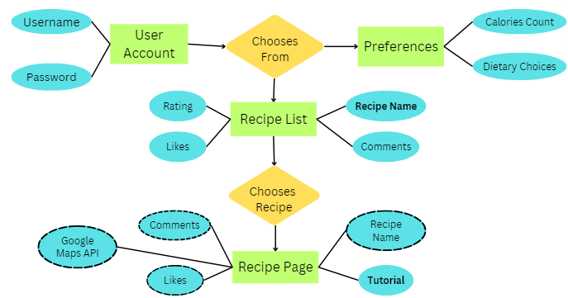
Appendix C: To Be Determined List
1. System Feature 3 (Most Liked Tab)
2. System Feature 4 (Most Reviewed Tab)
3. Performance Requirements
4. Safety Requirements
5. Security Requirements
6. Software Quality Attributes
7. Business Rules

------------------------------------------This Marks The End Of The SRS Report-----------------------------------------

